SVKM’s NMIMS
Mukesh Patel School of Technology Management & Engineering (Mumbai Campus)
Computer Engineering Department (B Tech CSE/CSBS Sem IV/BTI Sem VIII/MBA.Tech-IV)
Database Management System
Project Report
Program | Btech CSBS
Semester | IV
Name of the Project: | Vehicle Rental Management System
Details of Project Members
Batch | Roll No. | Name
B2 | E042 | Shreyash Nikam
B2 | E044 | Swapnil Pal
B2 | E050 | Soumya Ranasingh
Date of Submission: 26/02/2025

Contribution of each project Members:
Roll No. | Name: | Contribution
E042 | Shreyash Nikam | SQL Queries,Report
E044 | Swapnil Pal | Backend Development
E050 | Soumya Ranasingh | Frontend Development, Report

Github link of your project: https://github.com/ShreyashNikam17/Vehicle-Rental-System

Project Report

CAR RENTAL MANAGEMNET SYSTEM

by
Shreyash Nikam, Roll number: E042
Swapnil Pal, Roll number: E044
Soumya Subhankar Ranasingh,
Roll number: E050

Course: DBMS
AY: 2024-25

Table of Contents

Sr no. | Topic | Page no.
1 | Storyline | 4
2 | Components of Database Design | 5
3 | Entity Relationship Diagram | 8
4 | Relational Model | 9
5 | Normalization | 13
6 | SQL Queries | 14
7 | Project Demonstration | 24
8 | Self-learning beyond classroom | 36
9 | Learning from the project | 37
10 | Challenges faced | 38
11 | Conclusion | 42

I.Storyline
Imagine a city where every engine hum, every booking confirmation, and every returning customer adds a note to the ever-evolving symphony of urban mobility. In a world rapidly shifting towards on-demand convenience, the Car Rental System emerges—not just as software, but as a dynamic data ecosystem, designed to power every journey, from spontaneous weekend getaways to everyday urban commutes.

At its core, this project is about building a robust database system that becomes the operational backbone of a rental business. The system intricately records each critical detail: user registrations, vehicle availability, rental transactions, return logs, and admin updates. Each entry is more than a number—it’s a snapshot of movement, preference, and behavior.

The project unfolds in two powerful layers. First, the Java application integrated with MySQL via JDBC ensures a seamless interaction between users and data. Admins can add, update, or delete car entries; clients can create accounts, browse available vehicles, rent cars, and view their history—all through a user-friendly GUI. The system isn't just a set of menus; it's an intelligent assistant that tracks everything from car usage trends to user activity, instantly reflecting changes in the database.

Underneath this interaction lies SQL—used rigorously to extract, update, and manage data across multiple tables. Structured queries ensure data integrity and speed. Whether it’s verifying a password, checking if a car is already rented, or fetching rental history based on a client’s ID, the system responds with precision and efficiency.

The second layer is the strategic insight this data unlocks. Through this system, a rental business isn't just executing transactions—it’s learning. Admins can track the most rented cars, identify peak booking hours, detect idle inventory, and even foresee maintenance cycles based on usage patterns. The system evolves from a database to a business brain.

But this is more than a technical build—it’s empowerment. For a customer, it's a smooth rental experience, from login to key handover. For an admin, it’s complete visibility into the fleet and client base. And for the business, it’s a system that translates data into direction.

Ultimately, the Car Rental System DBMS project is a fusion of relational database architecture and real-world logic. It captures motion, records intention, and responds to demand—one transaction at a time. Behind every rented car is a story, and behind every story, a line of code that made it possible.

II. Components of Database Design

User
Attributes:
user_id (Primary Key)
first_name
last_name
email
phone_number
password
type (0 = Client, 1 = Admin)
Overview:
In your system, all registered individuals (admins and clients) are stored in the users table. The type attribute differentiates between Admin and Client roles. Every user has a unique user_id, and this table forms the backbone of the entire system.
________________________________________
Client
Derived from users where type = 0
Primary Key: user_id (also a Foreign Key from users)
Overview:
Clients are general users who can rent cars through the GUI. In your Java GUI, clients can:
Create accounts
View available cars
Rent cars
View their rental history
________________________________________
Admin
Derived from users where type = 1
Primary Key: user_id (also a Foreign Key from users)
Overview:
Admins are users with elevated privileges who can:
Add new cars
Update or delete cars
View all client rental histories
Manage the overall fleet
________________________________________
Car
Attributes:
car_id (Primary Key)
brand
model
color
year
price (hourly rate)
availability (1 = available, 0 = rented)
Overview:
This table maintains the inventory of cars available in the system. Each car is uniquely identified by car_id and contains detailed specifications including brand, model, and availability status. Admins manage this data through GUI operations like Add Car, Delete Car, and Update Car.
________________________________________
Rent
Attributes:
rent_id (Primary Key)
user_id (Foreign Key → users.user_id)
car_id (Foreign Key → cars.car_id)
date (rental date/time)
hours (number of hours rented)
total (calculated amount)
status (0 = ongoing, 1 = completed)
Overview:
This table logs each rental transaction. When a client rents a car via the GUI, a new record is inserted here. It tracks which client rented which car, for how long, and what total amount was paid. It's also used for showing client-specific rental history.
________________________________________
Relationships and Their Role in the Project
User – Client / Admin
Type: One-to-One
Participation:
User: Optional (a user can be created without a role initially)
Client/Admin: Mandatory (must map to an existing user)
Project Link:
In the system, roles are selected during account creation in the GUI. Admins and clients share the same base structure (users table) but operate with different GUI options and access rights.
________________________________________
Client – Rent
Type: One-to-Many
Participation:
Client: Optional (a client might not have rented yet)
Rent: Mandatory (each rental is done by a client)
Project Link:
Clients can rent multiple cars via the GUI. Their rentals are recorded in the rents table. Admins can view all rentals; clients can view only their own.
________________________________________
Car – Rent
Type: One-to-Many
Participation:
Car: Mandatory (every rental must be linked to an existing car)
Rent: Mandatory
Project Link:
When a car is rented, the car's availability is set to 0 (unavailable). The GUI triggers both an INSERT into rents and an UPDATE in cars.
________________________________________
Admin – Car
Type: One-to-Many
Participation:
Admin: Mandatory (each car should be registered by an admin)
Car: Optional (a car may exist before being assigned)
Project Link:
In the backend code (AddNewCar.java), an admin logs in and inserts new cars. You can expand this by linking cars to the admin_id for tracking who added what (a good future enhancement).

III. Entity Relationship Diagram

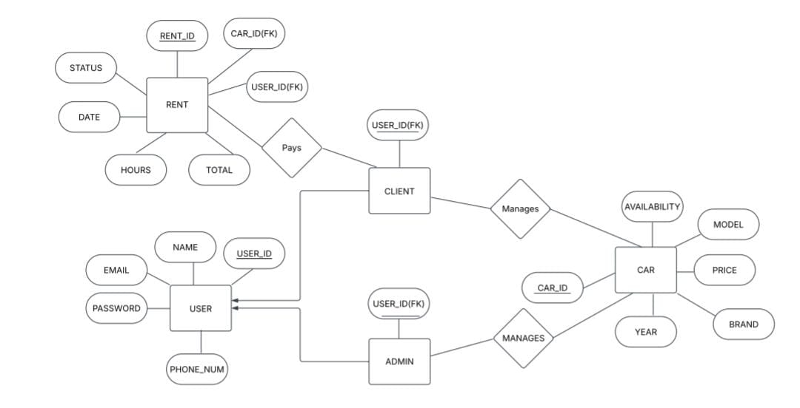

IV. Relational Model

1. USERS
Table Name: USERS
Attributes:
- user_id (Primary Key)
- name
- email
- password
- phone_num

Schema:
USERS(
user_id INT PRIMARY KEY,
name VARCHAR(100),
email VARCHAR(150) UNIQUE,
password VARCHAR(255),
phone_num VARCHAR(15) UNIQUE
);

2. CLIENT
Table Name: CLIENT
Attributes:
- user_id (Primary Key & Foreign Key → USERS.user_id)
Schema:
CLIENT(
user_id INT PRIMARY KEY REFERENCES USERS(user_id)
);

3. ADMIN
Table Name: ADMIN
Attributes:
user_id (Primary Key & Foreign Key → USERS.user_id)
Schema:
ADMIN(
user_id INT PRIMARY KEY REFERENCES USERS(user_id)
);

4. CAR
Table Name: CAR
Attributes:
- car_id (Primary Key)
- model
- brand
- year
- price
- availability
Schema:
CAR(
car_id INT PRIMARY KEY,
model VARCHAR(100),
brand VARCHAR(100),
year INT,
price DECIMAL(10, 2),
availability BOOLEAN
);

5. RENT
Table Name: RENT
Attributes:
- rent_id (Primary Key)
- user_id (Foreign Key → USERS.user_id)
- car_id (Foreign Key → CAR.car_id)
- status
- date
- hours
- total

Schema:
RENT(
rent_id INT PRIMARY KEY,
user_id INT FOREIGN KEY REFERENCES USERS(user_id),
car_id INT FOREIGN KEY REFERENCES CAR(car_id),
status VARCHAR(50),
date DATE,
hours INT,
total DECIMAL(10, 2)
);

6. ADMIN_CAR_MANAGEMENT
Table Name: ADMIN_CAR_MANAGEMENT
Attributes:
- admin_id (Foreign Key → ADMIN.user_id)
- car_id (Foreign Key → CAR.car_id)
Schema:
ADMIN_CAR_MANAGEMENT(
admin_id INT FOREIGN KEY REFERENCES ADMIN(user_id),
car_id INT FOREIGN KEY REFERENCES CAR(car_id),
PRIMARY KEY (admin_id, car_id)
);

V.Normalization
What is Normalization?
Normalization is a systematic process used to organize data in a way that reduces redundancy, eliminates data anomalies, and ensures data integrity.
It involves dividing large, complex tables into smaller, related ones and defining relationships between them using keys (primary and foreign).
There are 3 types of Normal Form:
- 1st Normal Form(1NF)
- Definition: First Normal Form (1NF) is a property of a relational database table that ensures all the data in each column is atomic, meaning each field contains only one value, and that there are no repeating groups or duplicate rows. This form ensures that the table structure is organized, readable, and suitable for further normalization.
- Where is it used:
- Tables like USERS, CAR, RENT, etc., have clearly defined atomic fields: name, email, phone_num, model, brand, availability, etc.
- No multivalued fields like rented_car1, rented_car2 etc.
- 2nd Normal Form(2NF)
- Definition: Second Normal Form (2NF) is achieved when a table is already in First Normal Form (1NF) and all non-key attributes are fully functionally dependent on the entire primary key. This means there should be no partial dependency, where a non-key column depends on only a part of a composite primary key. If the table has a single-column primary key, it automatically satisfies this condition if it's in 1NF.
- Where is it used:
- Tables like CLIENT, ADMIN, CAR, USERS have single primary keys.
- Even in the ADMIN_CAR_MANAGEMENT table, which has a composite key (admin_id, car_id), there are no non-prime attributes—only the keys exist.
- 3rd Normal Form(3NF)
- Definition: Third Normal Form (3NF) is achieved when a table is already in Second Normal Form (2NF) and all non-key attributes are directly dependent on the primary key only, and not on other non-key attributes.There should be no transitive dependency, where a non-key column depends on another non-key column instead of directly on the primary key.
- Where is it used:
- In USERS, email, name, password, phone_num all depend only on user_id.
- In RENT, status, date, hours, total depend only on rent_id.
- RENT.total might seem like a derivable field (from price × hours), but as it's stored directly, it's not violating 3NF.
VI.SQL Queries

1)

2) 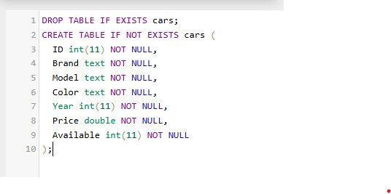

3) 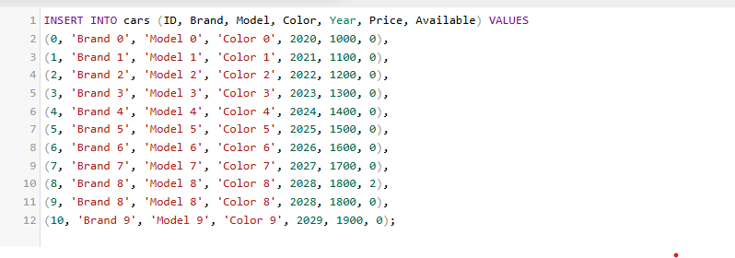

4) 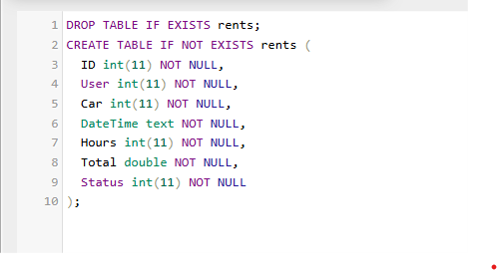

5) 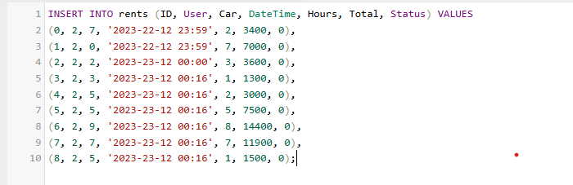

6) 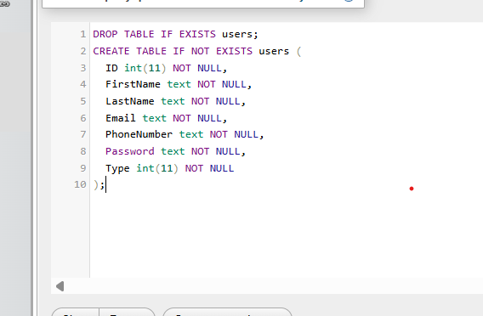

7) 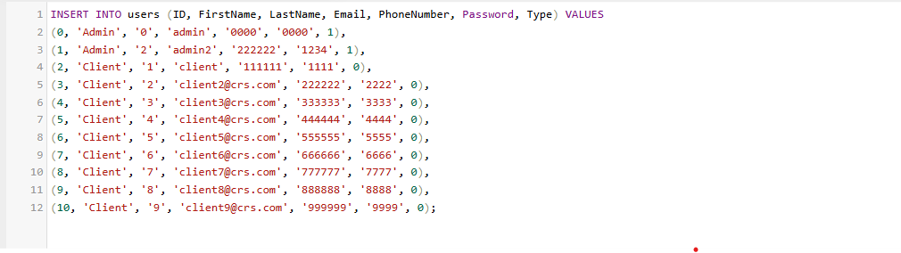

8) 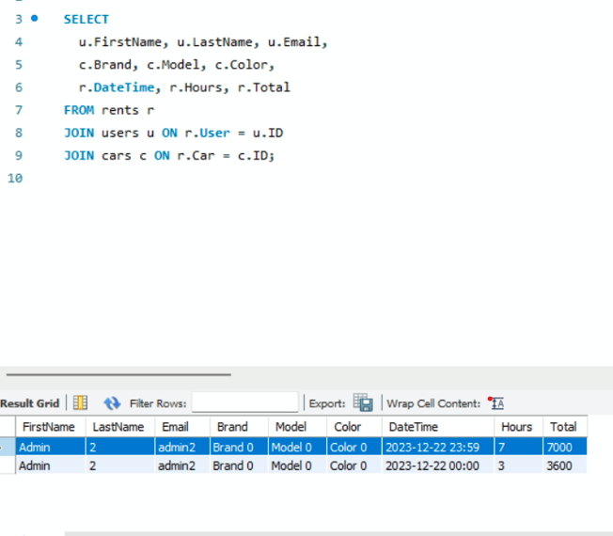

9) 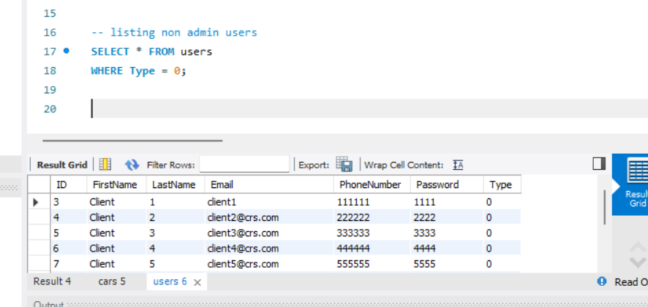

10) 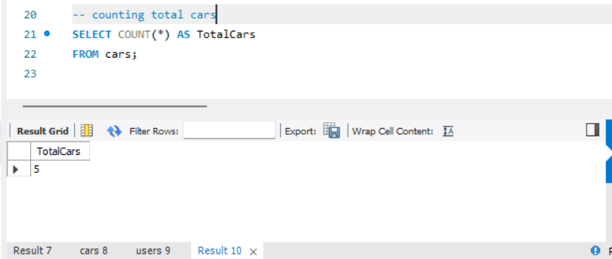

11) 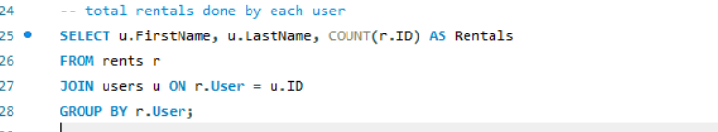

12) 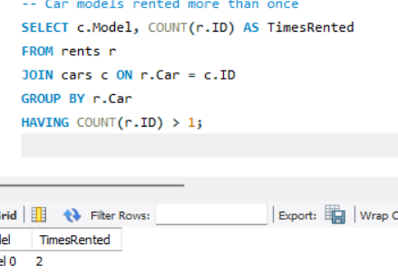

13) 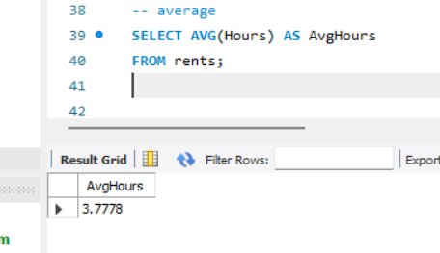

14) 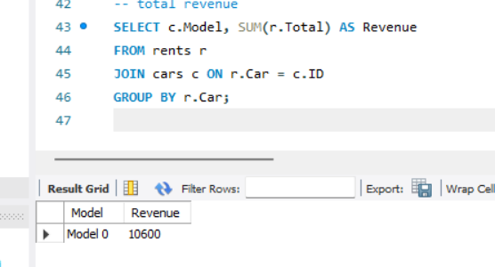

15) 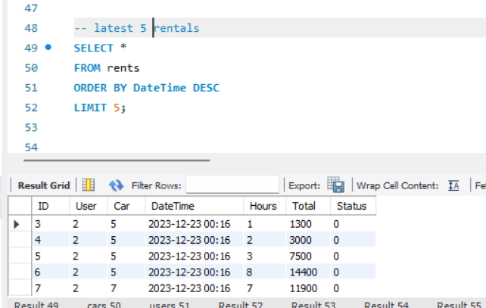

16) 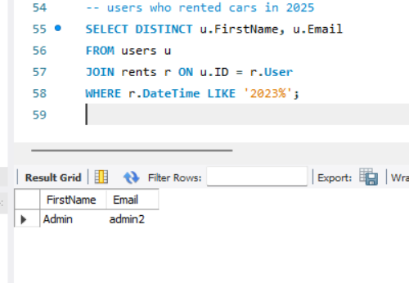

17) 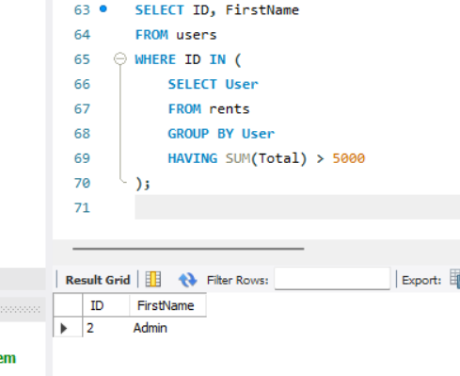

18) 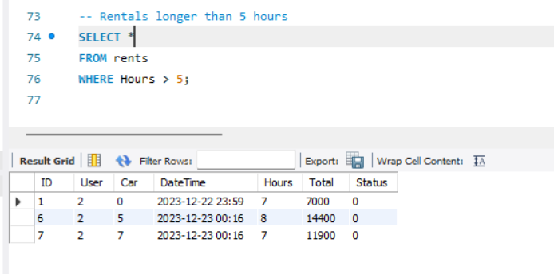

19) 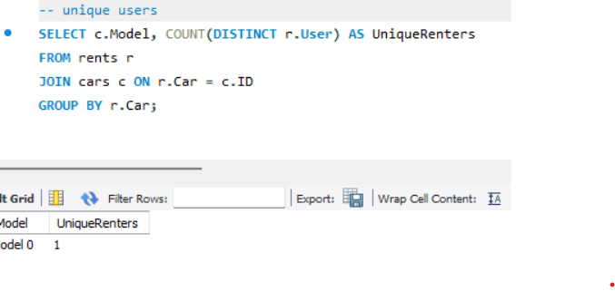

20) 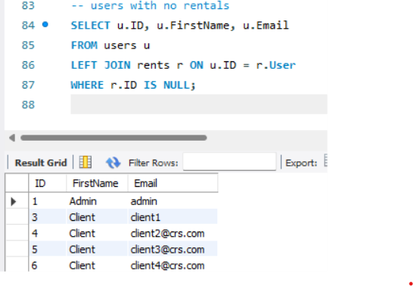

VII.PROJECT DEMONSTRATION

Tool / Software | Purpose
Eclipse IDE | Java code development and GUI design using Swing
Java (JDK 21) | Backend programming language; used for logic and JDBC connectivity
MySQL | Relational Database Management System used to store and manage data
phpMyAdmin | Web-based interface to create, modify, and view the MySQL database
XAMPP | Local server environment to run MySQL and phpMyAdmin locally
MySQL Workbench | SQL query development, ER modeling, and execution with joins/analytics
JDBC (Java Connectivity) | Connects Java application to MySQL database
Swing (Java GUI Library) | Used to build the graphical interface for login, car management, etc.

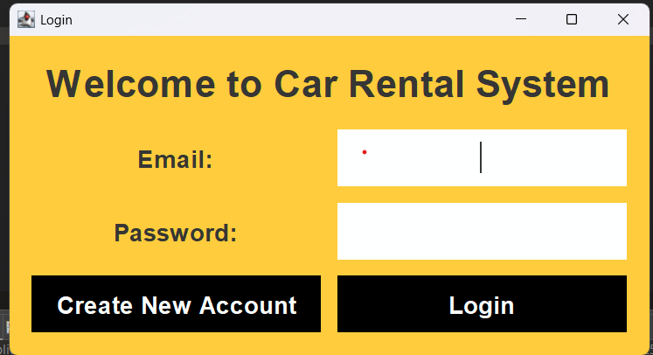

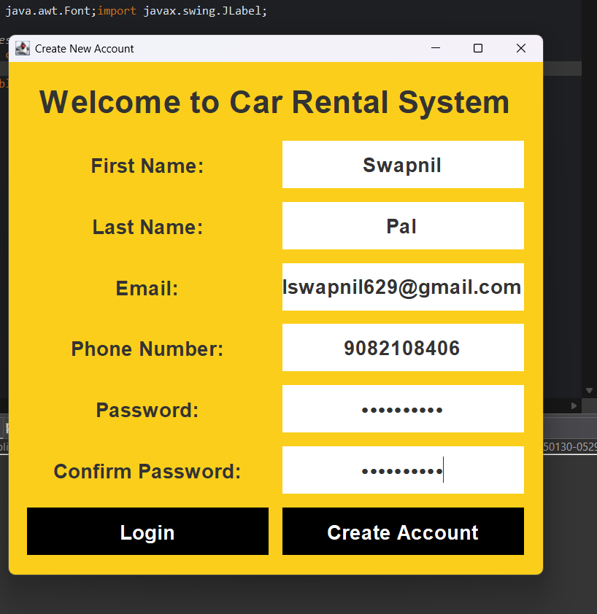

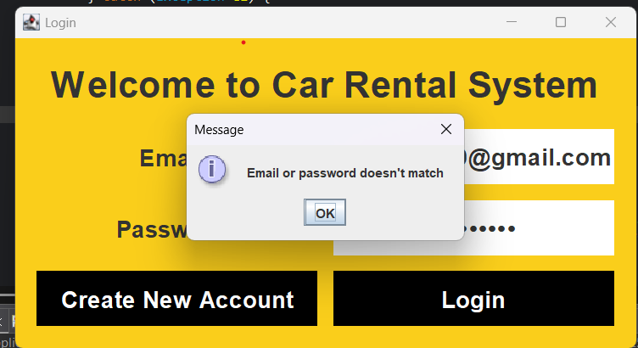

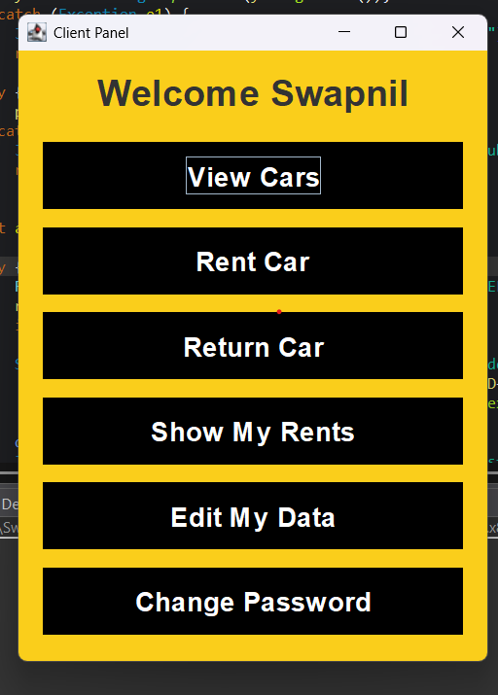

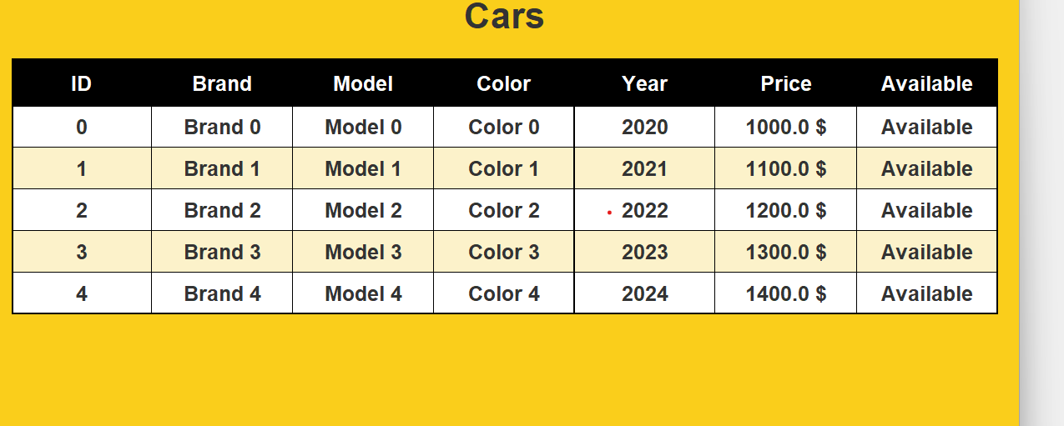

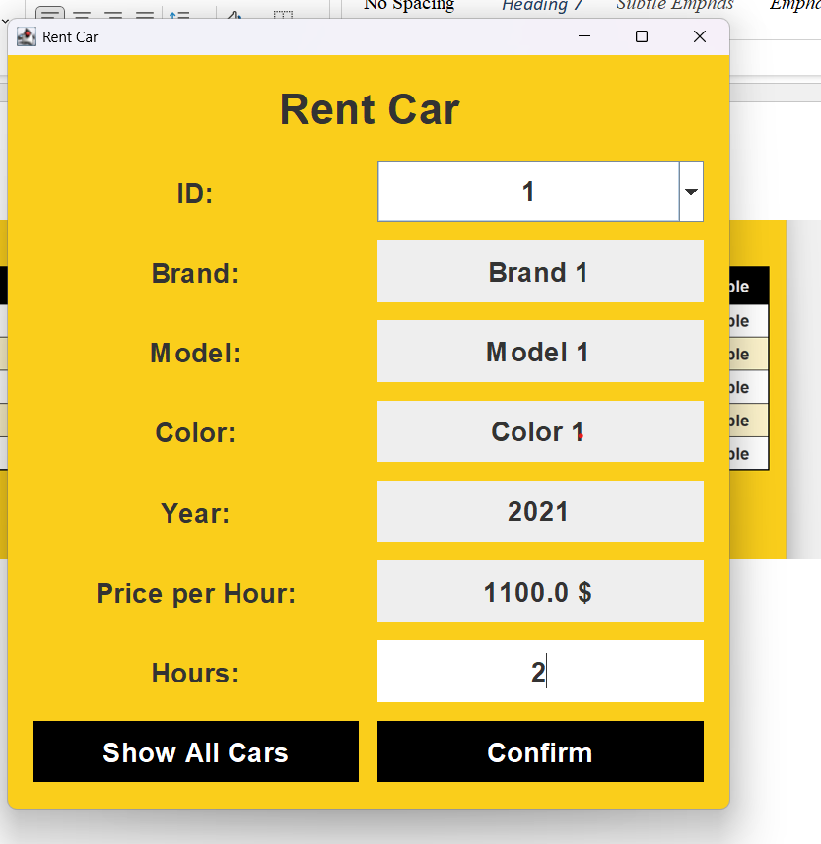

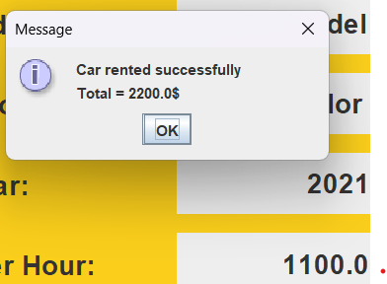

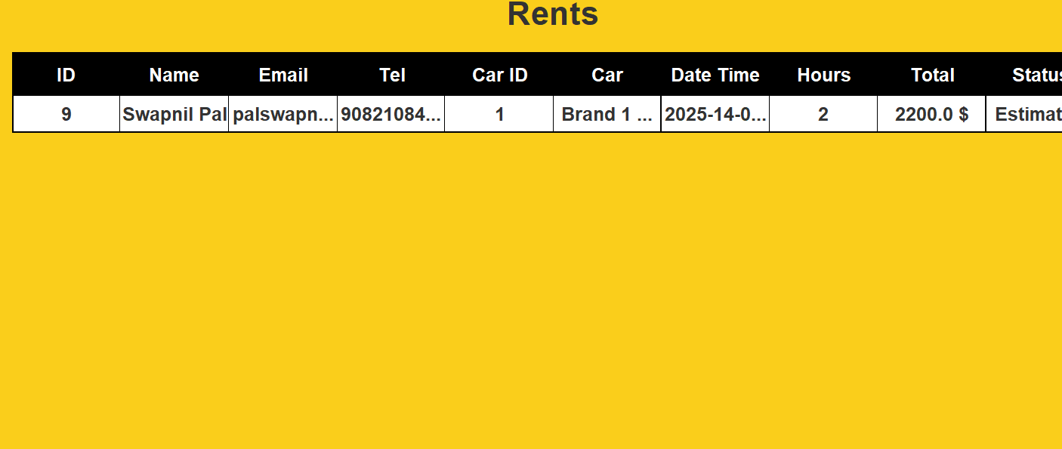

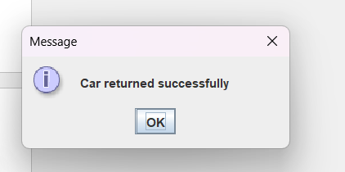

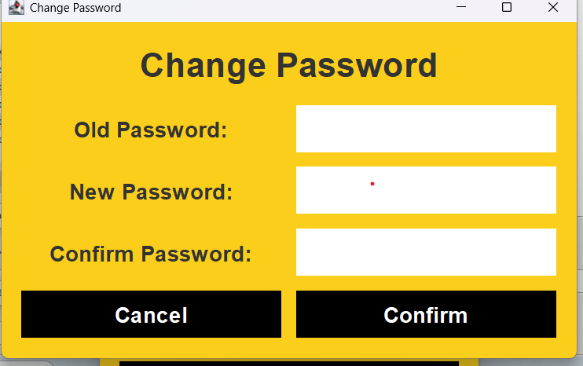

IMPLEMENTATION OF THE PROJECT:
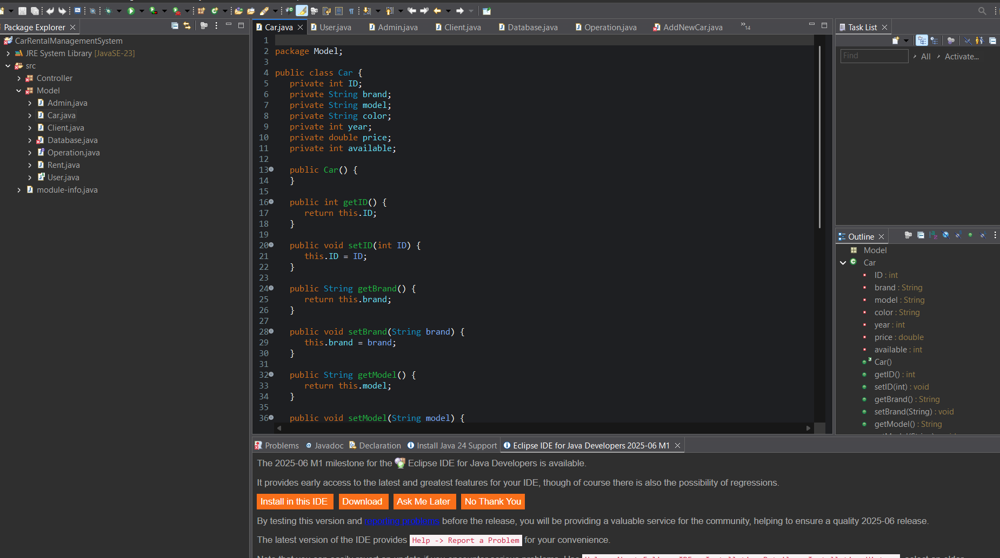
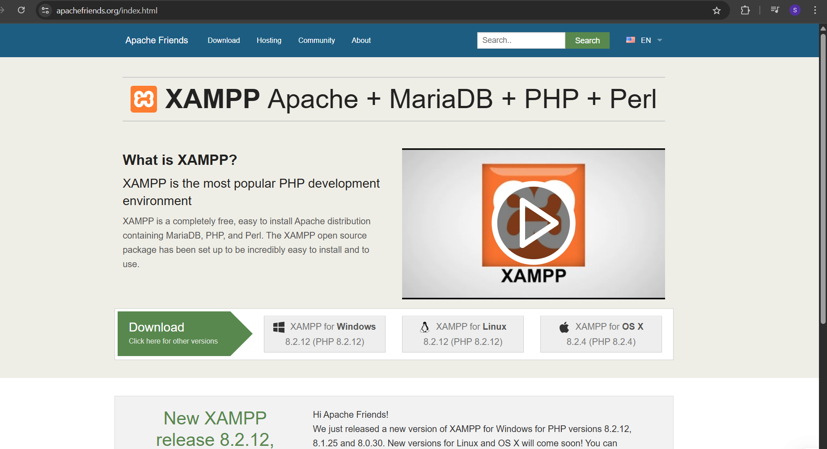
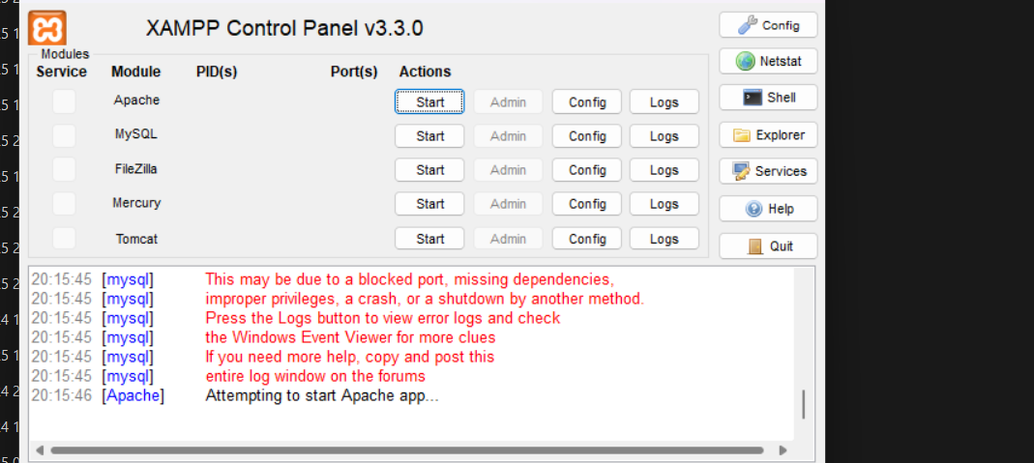

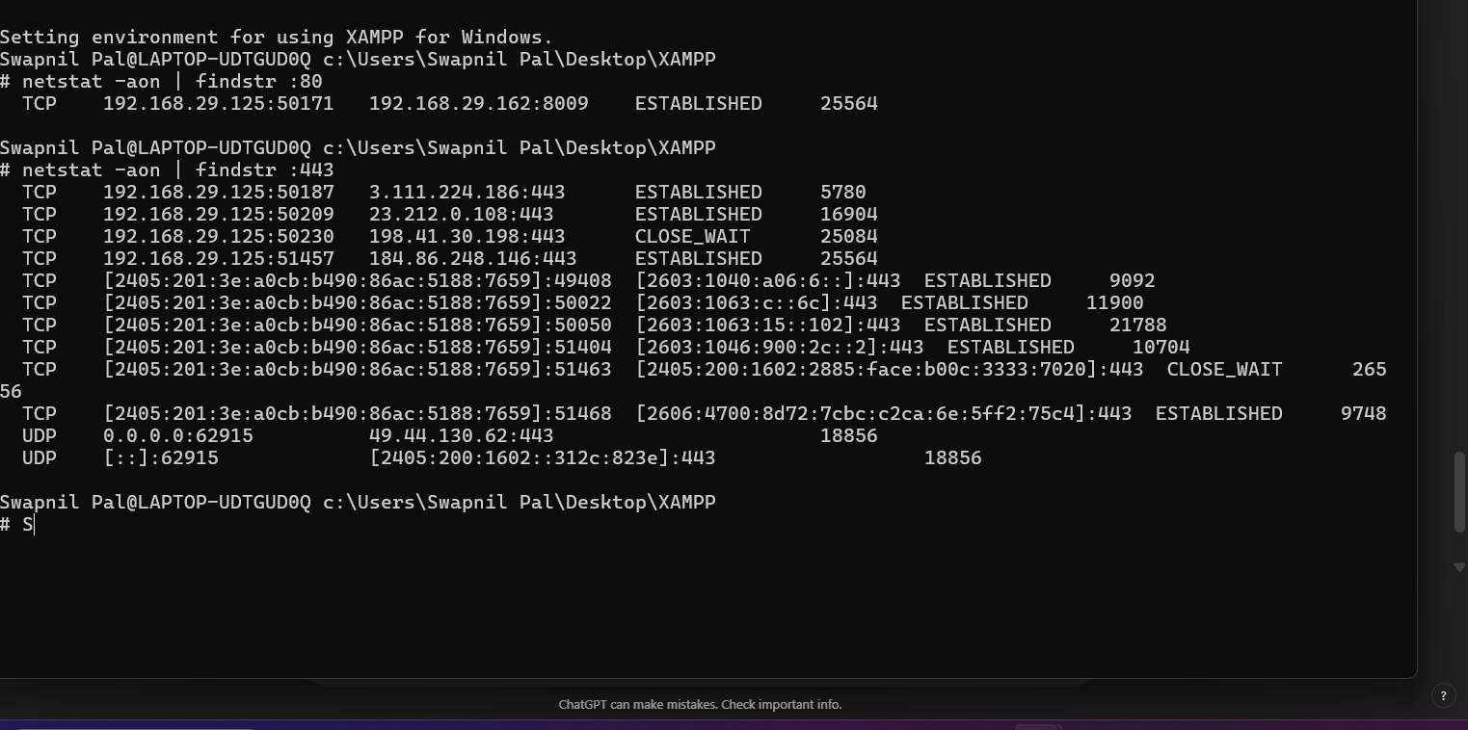

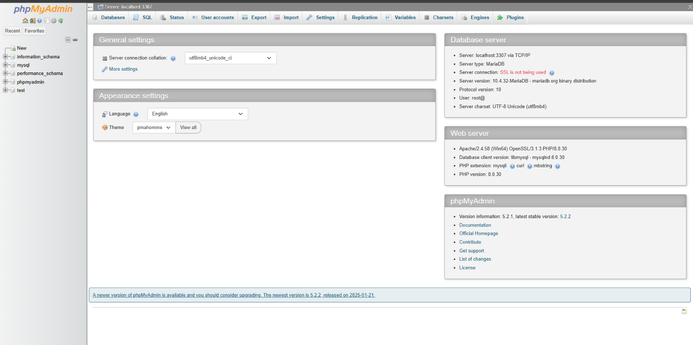

VIII. SELF LEARNING BEYOND THE CLASSROOM

This project required exploring technologies and tools that extended far beyond the classroom curriculum. While classroom sessions typically focus on theoretical knowledge of DBMS concepts and basic SQL, this project encouraged deep dives into:
- phpMyAdmin usage: While MySQL was taught, GUI-based operations in phpMyAdmin like table creation, relationship setup, indexing, and executing raw SQL required individual experimentation.
- MySQL Workbench for query visualization: Beyond phpMyAdmin, Workbench helped in writing more complex join queries and understanding the schema at a broader level.
- Java GUI development using Swing: Implementing front-end interfaces like login forms, account creation, and rental operations using Java Swing was largely self-taught.
- JDBC Integration: Understanding how Java connects to a database via JDBC wasn’t just about copying code; it involved learning driver loading, connection handling, statement execution, and result parsing.

IX. LEARNING FROM THE PROJECT

This project brought together various DBMS and programming concepts into one real-life use case. Key learnings include:
- Database Design: Designing a clean and normalized schema with proper keys, constraints, and relationships for entities like users, cars, and rents.
- CRUD Operations: Implementing Create, Read, Update, and Delete functionality via both SQL and Java code gave a practical understanding of data manipulation.
- Query Writing and Joins: Gained experience writing SELECT, UPDATE, and DELETE queries, especially with INNER and OUTER JOINS to connect multiple tables and retrieve combined data (e.g., user rent history).
- Java Exception Handling: Dealing with common runtime exceptions such as SQLException, NullPointerException, and connection issues taught the importance of robust error management.
- User Management System: Designing different access levels for admins and clients deepened understanding of role-based access control in databases and applications.
- GUI Integration: Creating a responsive and user-friendly interface using Java Swing improved front-end logic design and event handling.

X. CHALLENGES FACED
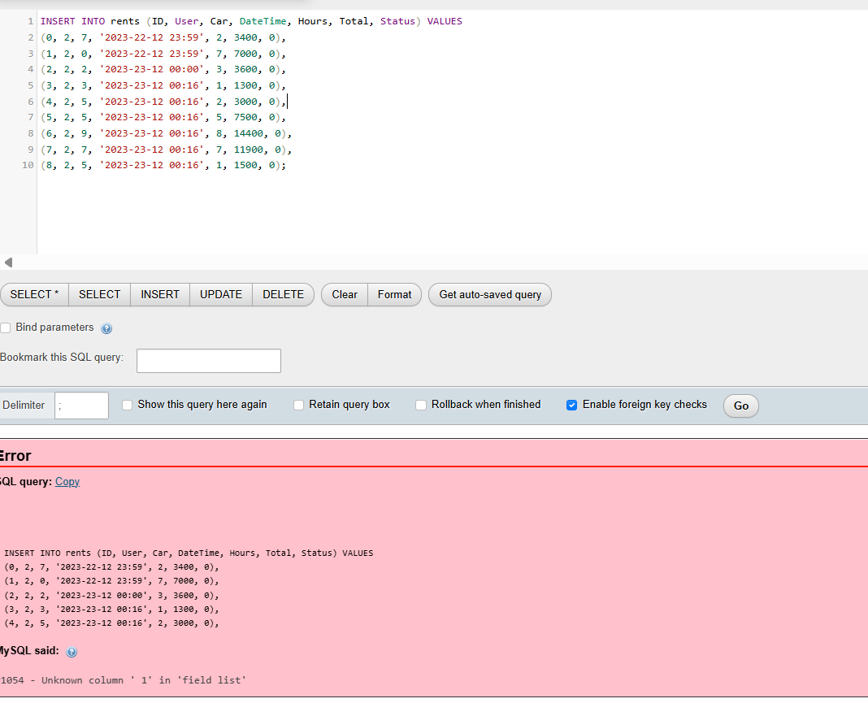
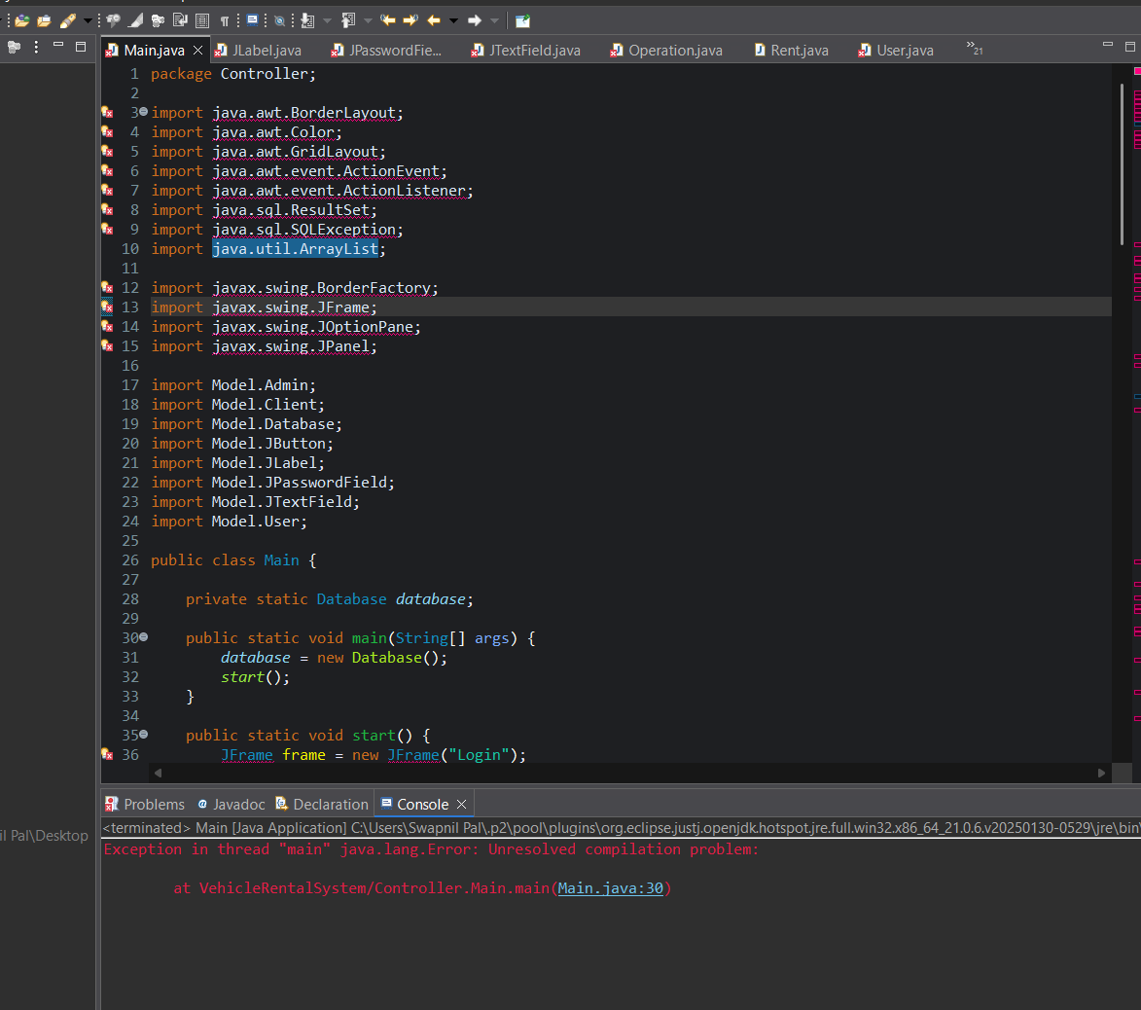

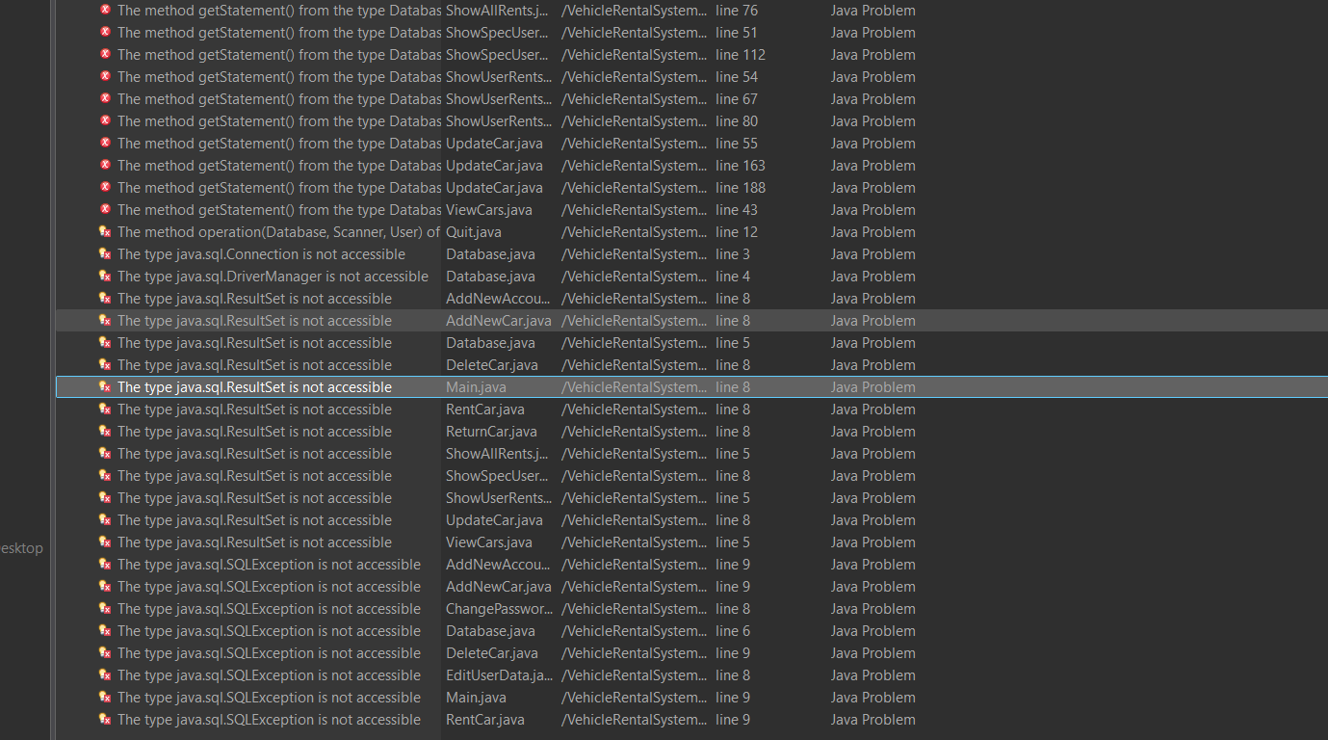

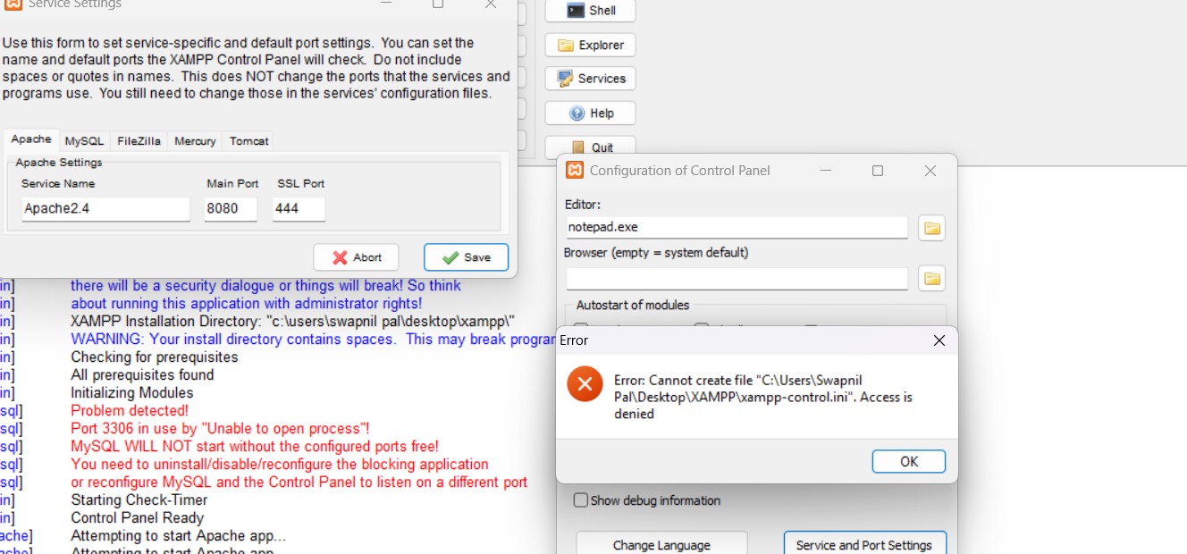

Throughout the development of the Car Rental System project, we encountered several real-world challenges that tested our understanding and problem-solving skills beyond the textbook. One of the earliest issues was related to database connectivity between Java and MySQL. Even though we included the JDBC connector, the connection failed multiple times due to incorrect port configuration and credential mismatches. This led us to understand the importance of checking default MySQL port settings (in our case, port 3307 on XAMPP) and ensuring consistency between phpMyAdmin and Eclipse JDBC setup.

Another frequent issue was SQL exceptions thrown during runtime. Often, these occurred due to syntactical mistakes, missing primary keys, or violations of foreign key constraints. For example, while inserting data into the rents table, we received duplicate entry errors for the ID field because it wasn’t auto-incremented. Additionally, referencing foreign keys that didn’t exist yet caused failures until we learned to insert dependent data first or adjust the schema accordingly.

Working with Swing GUI in Java presented its own set of complexities. Laying out buttons, labels, and input fields in a visually clean manner was difficult without understanding layout managers. At times, our application windows appeared misaligned or controls overlapped, so we had to explore layout strategies like GridLayout and BorderLayout to get it right. Also, handling button actions and triggering SQL queries from within the GUI involved learning about ActionListeners and managing input data effectively.

We also faced difficulty when switching to MySQL Workbench for writing advanced queries. Unlike phpMyAdmin, Workbench required us to explicitly set the default schema using the USE command, which we initially overlooked. This caused queries to fail with “no database selected” errors until we learned how to configure schemas properly. Complex INNER JOIN and LEFT JOIN queries required a clear understanding of relationships across users, cars, and rents tables, and we had to carefully design our queries to avoid ambiguous column references.

One of the most conceptually challenging aspects was ensuring the database adhered to normalization standards. While 1NF was relatively straightforward, applying 2NF and 3NF in a practical scenario required us to remove partial and transitive dependencies — especially when dealing with attributes like brand, model, and availability. We refined our relational model multiple times to ensure that no redundant or repeating data was present.

Lastly, working with user roles (Admin vs Client) in the system required thoughtful validation. Ensuring that each user could only access relevant features involved logic both in the database and the front-end Java interface. Building this role-based access control improved the system’s security and professionalism but was only possible after careful design and debugging.

XI. CONCLUSION

The Vehicle Rental Management System DBMS project was not just a coding task about MY SQL queries and Java— it was a deep exploration of real-world application development. It helped us connect abstract database concepts with concrete implementation using tools like Java, JDBC, phpMyAdmin, and MySQL Workbench. From designing schemas to querying relational data and integrating with a functional Java interface, we walked through the complete development lifecycle.
This project helped us to sharpened our logical thinking, programming skills, database fluency, and presentation abilities. It prepared us not only for DBMS exams but also for future internships and industry-level full-stack development. Most importantly, it taught us how to learn independently, troubleshoot problems, and turn theory into impactful applications.

